CISCO NETWORKING REPORT
REPORT
Table of Contents
PROJECT 1: Design and Implementation of a Small Office Home Office Network -SOHO 3
INTRODUCTION 3
The key objectives of this project include: 4
NETWORK DESIGN 4
NETWORK TOPOLOGY DIAGRAM 4
Base Network: 5
IP ADDRESSING 6
VLAN CONFIGURATION 6
Router Configurations 7
The DHCP pools for each VLAN are configured as follows: 8
VLAN CONFIGURATION 8
Configure VLAN Interfaces: 8
SWITCH CONFIGURATION 9
Trunk link Configuration 9
Wireless network settings 10
Wireless Network Security Guidelines 10
Wireless network configuration 11
Access point configuration 11
TESTING 11
PDU TEST 11
WAP LOGIN 12
Conclusion 12
PROJECT 2: Design and Implement a Hotel Network 13
Introduction 13
The key requirements 13
Network Design 14
Network Topology Diagram 14
IP ADRESSING SCHEME 14
ROUTERS 14
ROUTER CONFIGURATIONS 15
Serial DCE Connections and Clock Rate 15
Example configuration for Router 0 using the router cli: 16
VLAN Configuration 16
Configuring DHCP Service Pools and Encapsulation 16
Figure 2.4 router1 (2nd floor) DHCP pools and dns config 16
Configuring OSPF Routing Protocol 17
Example configuration for Router 1: floor 1 18
SSH Configuration 18
Trunk Links Configuration 18
Switch Configurations 18
VLAN Configuration 18
Port Security Configuration (for IT Department Switch) 19
Wireless Network Configuration 20
Access point floor 1, 2 and 3 configuration 20
1. Floor 1 20
2. Floor 2 20
3. Floor 3 21
Testing and Verification 22
1. Several ping commands from different vlans in the network 22
2. Wap connection 22
3. Assigning of ip addresses e.g. floor 2 23
4. PDU test 23
Enhanced Security Measures 23
Conclusion 24
Accomplishments 25

PROJECT 1: Design and Implementation of a Small Office Home Office Network -SOHO

INTRODUCTION
In today's interconnected world, the establishment of robust network infrastructures is essential for the seamless operation and growth of businesses. XYZ Company, a rapidly expanding enterprise based in Nairobi with a global customer base exceeding 2 million, is poised to extend its reach by opening a branch in Kisumu. To facilitate the smooth functioning of this new branch, XYZ Company has entrusted a team of young IT graduates with the task of designing and implementing a tailored network solution.
This project aims to address the unique requirements of XYZ Company's branch in Kisumu, ensuring that its network infrastructure aligns with the company's operational needs and supports its ongoing success. As a small network deployment, careful consideration must be given to the selection of network devices, configuration of virtual local area networks (VLANs), provision of wireless connectivity, and implementation of automatic IP address assignment.

The key objectives of this project include:
- Selecting appropriate Cisco products, specifically one router and one switch, to form the foundation of the network infrastructure.
- Designing VLANs to segregate the network into distinct departments, namely Admin/IT, Finance/HR, and Customer Service/Reception, in accordance with XYZ Company's organizational structure.
- Establishing wireless networks within each department to accommodate the mobility needs of users.
- Implementing DHCP (Dynamic Host Configuration Protocol) to enable host devices to automatically obtain IPv4 addresses, thereby simplifying network management.
- Facilitating seamless communication between devices in all departments to promote collaboration and efficiency within the branch.
By leveraging the Cisco Packet Tracer application, my project endeavors to provide a comprehensive solution that meets the specified requirements while adhering to industry best practices and standards. Through careful planning, configuration, and testing, the resulting network infrastructure will empower XYZ Company's branch in Kisumu to operate autonomously and efficiently, contributing to the company's continued growth and success.

NETWORK DESIGN

NETWORK TOPOLOGY DIAGRAM
Figure 1.1: XYZ Company's Kisumu Branch Network Topology
To fulfill the network requirements for XYZ Company's Kisumu branch, a comprehensive network design will be implemented as depicted in Figure 1.1
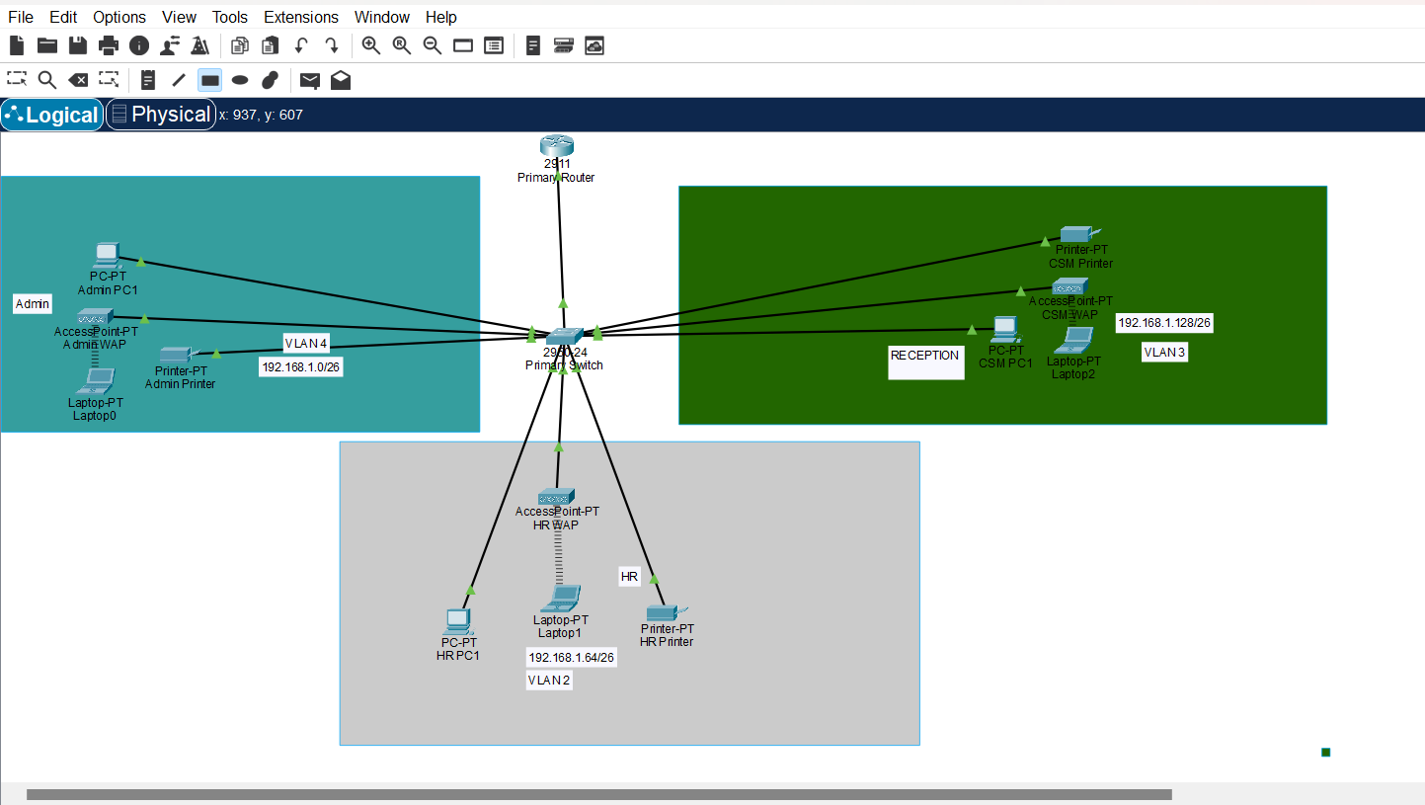

Base Network:
The ISP has provided a base network of 192.168.1.0/24, offering a range of 254 host addresses. This subnet will serve as the foundation for the entire network infrastructure, providing connectivity and addressing for all devices within the branch.
Departments:
- Admin/IT: This department, responsible for administrative tasks and IT operations, will be allocated VLAN 4 for network segmentation and security. VLAN 4 will facilitate the isolation of Admin/IT department devices from other departments, ensuring dedicated resources and enhanced security.
- Finance/HR: Handling financial and human resources management, the Finance/HR department will be assigned VLAN 2. VLAN 2 will segregate Finance/HR department devices from other network segments, safeguarding sensitive financial and personnel data.
- Customer Service/Reception: Tasked with customer interactions and reception services, the Customer Service/Reception department will utilize VLAN 3. VLAN 3 will enable efficient communication and collaboration within the department while maintaining separation from other network segments.
- Wireless: A separate VLAN, VLAN 1, will be designated for wireless network access. This VLAN will cater to wireless devices across all departments, providing ubiquitous connectivity while adhering to stringent security measures to safeguard network integrity.

By implementing this network design, XYZ Company's Kisumu branch will benefit from a structured and secure network infrastructure tailored to meet the diverse operational needs of its departments. This design ensures efficient communication, optimal performance, and robust security across the entire network topology.

IP ADDRESSING
- number of subnets required:
4 subnets (1 for each department)
Calculate the number of bits to borrow from the host portion:
Number of subnets required = 2^n
4 = 2^2
n = 2 (borrow 2 bits from the host portion)

New Subnet Mask = 255.255.255.192 (/26)
- number of usable IP addresses per subnet:
Usable IP addresses per subnet = 2^ (Host Bits) - 2
Host Bits = 32 - 24 (from /24) - 2 (borrowed bits) = 6
Usable IP addresses per subnet = 2^6 - 2 = 62
Subnet IP Address Ranges:
Subnet 1 (Admin/IT): 192.168.1.0 - 192.168.1.63
Subnet 2 (Finance/HR): 192.168.1.64 - 192.168.1.127
Subnet 3 (Customer Service/Reception): 192.168.1.128 - 192.168.1.191
Subnet 4 (Wireless): 192.168.1.192 - 192.168.1.255

VLAN CONFIGURATION
Figure 1.2: VLAN Implementation for XYZ Company's Kisumu Branch Network
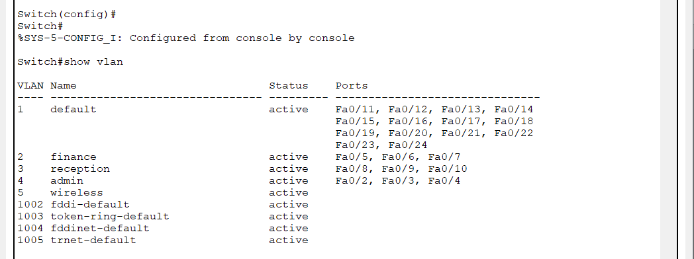
In the network architecture of XYZ Company's Kisumu branch, Virtual Local Area Networks (VLANs) are strategically implemented to achieve logical segmentation and bolster security by segregating traffic among various departments. The VLAN configuration is as follows:

VLAN 1: Assigned to the Wireless Network.
VLAN 2: Assigned to the Finance/HR department.
VLAN 3: Assigned to the Customer Service/Reception department.
VLAN 4: Assigned to the Admin
By deploying VLANs, the network traffic is efficiently partitioned, leading to enhanced security and optimized network performance. Devices within the same VLAN can communicate seamlessly, fostering collaboration and resource sharing within respective departments. However, communication between devices in distinct VLANs is meticulously regulated and routed through the router. This meticulous control ensures proper segregation and enforcement of security policies, preventing unauthorized access and fortifying the integrity of the network infrastructure.
Through the adept utilization of VLAN technology, XYZ Company's Kisumu branch network achieves a harmonious balance between accessibility and security, paving the way for streamlined operations and robust data protection.

Router Configurations
Process of sub netting:
VLAN 4 (Admin/IT): 192.168.1.0/25 (Subnet Mask: 255.255.255.128)
Usable IP Address Range: 192.168.1.1 - 192.168.1.126
Default Gateway: 192.168.1.1
VLAN 2 (Finance/HR): 192.168.1.128/25 (Subnet Mask: 255.255.255.128)
Usable IP Address Range: 192.168.1.129 - 192.168.1.254
Default Gateway: 192.168.1.129
VLAN 3(Customer Service/Reception): 192.168.1.256/25 (Subnet Mask: 255.255.255.128)
Usable IP Address Range: 192.168.1.257 - 192.168.1.382
Default Gateway: 192.168.1.257
The router is configured as the DHCP (Dynamic Host Configuration Protocol) server for the network. It is responsible for automatically assigning IP addresses, subnet masks, default gateways, and other network configuration parameters to devices within each VLAN.

The DHCP pools for each VLAN are configured as follows:
VLAN 4 DHCP Pool: 192.168.1.2 - 192.168.1.126
VLAN 2 DHCP Pool: 192.168.1.130 - 192.168.1.254
VLAN 3 DHCP Pool: 192.168.1.258 - 192.168.1.382
Devices in each department will obtain IP addresses from the respective DHCP pool associated with their VLAN. The router acts as the default gateway for each subnet, facilitating inter-VLAN communication and providing access to external resources.
With this configuration, the network will use the provided base network of 192.168.1.0/24, divided into four subnets (/26) for the different departments and the wireless network. The router acts as the DHCP server, providing IP addresses to devices in each VLAN and subnet.
Devices in each department will obtain IP addresses from the respective DHCP pool, and inter-VLAN routing will allow communication between devices in different departments and the wireless network.

VLAN CONFIGURATION
To enable inter-VLAN routing and assign IP addresses to the VLANs, the following configurations are performed on the switch:
Enable IP Routing: The switch's IP routing functionality is enabled to allow routing between VLANs.

Configure VLAN Interfaces:
VLAN 4 (Admin/IT): The VLAN 10 interface is assigned the IP address 192.168.1.1 with a subnet mask of 255.255.255.192.
VLAN 2 (Finance/HR): The VLAN 20 interface is assigned the IP address 192.168.1.65 with a subnet mask of 255.255.255.192.
VLAN 3 (Customer Service/Reception): The VLAN 30 interface is assigned the IP address 192.168.1.129 with a subnet mask of 255.255.255.192.
VLAN 4 (Wireless): The VLAN 4 interface is assigned the IP address 192.168.1.193 with a subnet mask of 255.255.255.192.

SWITCH CONFIGURATION

Trunk link Configuration
The switch port connected to the router is configured as a trunk link, allowing the switch to carry traffic for multiple VLANs over a single link. This configuration enables inter-VLAN communication through the router.
Figure 1.4 illustrates the trunk link configuration, where the switch port connected to the router is set as a trunk port, facilitating the exchange of traffic between different VLANs.
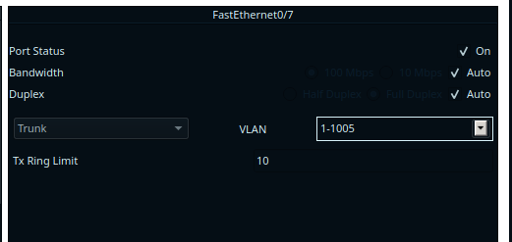

Wireless network settings
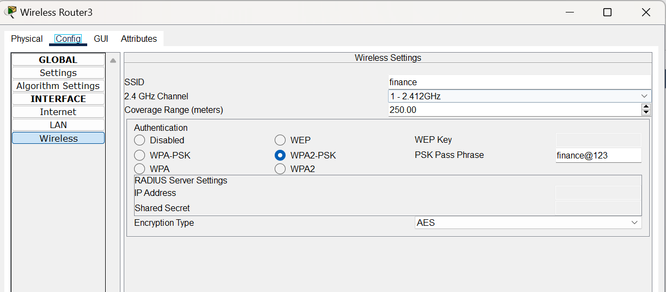

Wireless Network Security Guidelines
To guarantee secure wireless communication and fortify the network against unauthorized access, we adopt the following Wireless Network Security Guidelines:

- Wi-Fi Protected Access 2 (WPA2) Encryption: Employ WPA2 encryption as the standard for securing wireless networks. WPA2 offers robust protection against various security threats and is widely recognized as a secure encryption standard.
- Pre-Shared Key (PSK) Authentication: Implement Pre-Shared Key authentication method with WPA2 encryption. PSK ensures that only authorized users with the correct passphrase can access the wireless network, adding an extra layer of security.
- Strong Passphrase Policy: Enforce a policy for strong passphrases to enhance security. Passphrases should be complex, consisting of a combination of uppercase and lowercase letters, numbers, and special characters, and should be at least 12 characters long.
- Network Segmentation: Segment the wireless network from other network segments to limit the potential impact of security breaches. Use VLANs or separate subnets to isolate wireless devices from critical network resources.
- User Authentication and Access Control: Utilize additional authentication methods, such as 802.1X/EAP (Extensible Authentication Protocol), for user authentication on the wireless network. Implement access control policies to restrict access based on user roles and permissions.
- Wireless Intrusion Prevention Systems (WIPS): Deploy wireless intrusion prevention systems to detect and prevent unauthorized access, rogue access points, and other wireless security threats. WIPS solutions provide continuous monitoring and enforcement of wireless security policies.
- Security Awareness Training: Provide security awareness training to employees and users to educate them about wireless security best practices, such as avoiding connecting to unsecured networks and recognizing phishing attempts.
- By adhering to these Wireless Network Security Guidelines, we can ensure the confidentiality, integrity, and availability of our wireless network infrastructure while minimizing the risk of unauthorized access and security breaches.

Wireless network configuration

Access point configuration
SSID | encryption | Passphrase | department
admin | WPA2-PSK | ADMIN011 | Admin
HR | WPA2-PSK | RESOURCE33 | Human resource
RECEPTION | WPA2-PSK | RECEPTION44 | Customer Service/Reception

TESTING

PDU TEST

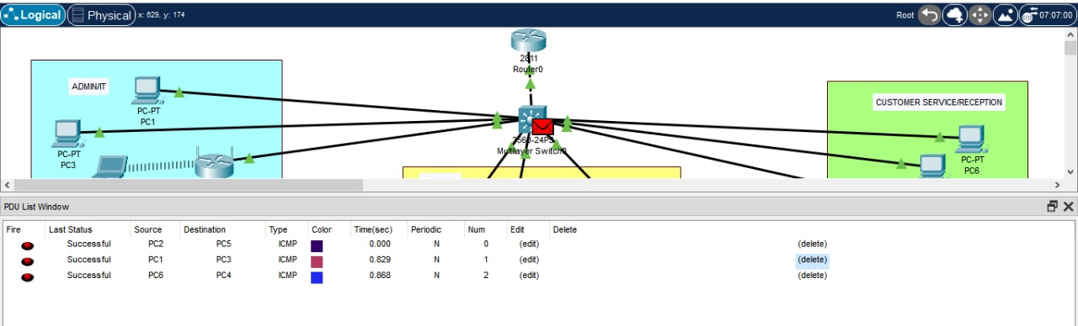

WAP LOGIN
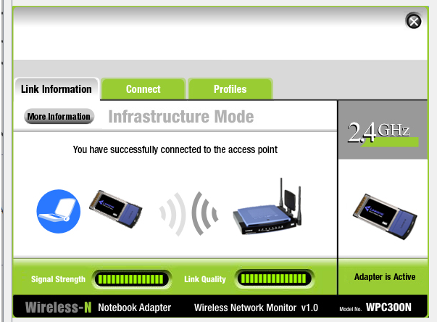

Conclusion
In conclusion, the design and implementation of the Small Office Home Office (SOHO) network for XYZ Company's branch in Kisumu represent a culmination of meticulous planning, configuration, and testing aimed at fostering efficient communication, robust security, and seamless operations within the organization. Throughout this project, careful consideration was given to XYZ Company's specific requirements, organizational structure, and operational needs, resulting in a tailored network solution that aligns with industry best practices and standards.

By leveraging Cisco Packet Tracer and adhering to established networking principles, the project team successfully designed a network topology that accommodates the diverse departments of XYZ Company's Kisumu branch while ensuring logical segmentation, optimal performance, and stringent security measures. The deployment of Virtual Local Area Networks (VLANs) enables the isolation of network traffic, enhancing security and resource allocation across departments.

Furthermore, the implementation of Dynamic Host Configuration Protocol (DHCP) simplifies network management by automating the assignment of IP addresses and other configuration parameters, reducing administrative overhead and ensuring scalability. Inter-VLAN routing facilitates seamless communication between devices in different departments, promoting collaboration and productivity.

The adoption of Wireless Network Security Guidelines, including WPA2 encryption with Pre-Shared Key (PSK) authentication, network segmentation, user authentication, and wireless intrusion prevention systems, underscores XYZ Company's commitment to safeguarding its wireless network infrastructure against unauthorized access and security breaches.

In summary, the successful completion of this project equips XYZ Company's Kisumu branch with a resilient, scalable, and secure network infrastructure that supports its ongoing growth and operational objectives. Through effective collaboration, technical expertise, and adherence to best practices, the project team has demonstrated its capability to deliver tailored network solutions that meet the evolving needs of modern enterprises.

PROJECT 2: Design and Implement a Hotel Network

Introduction
The network infrastructure for the Murang’a Modern Hotel is designed to facilitate seamless communication and efficient operations across its three floors, each housing distinct departments. Comprising robust Cisco networking equipment, including routers, switches, and wireless access points, the network ensures reliable connectivity and optimal performance.
At the heart of the network are three Cisco 2911 Series routers, strategically positioned in the IT department's server room. These routers are interconnected using serial DCE cables, establishing communication channels between the floors with IP addresses allocated within the 10.10.10.0/30, 10.10.10.4/30, and 10.10.10.8/30 subnets. Each floor is equipped with a Cisco Catalyst 2960 Series switch, facilitating local network connectivity and departmental segmentation. Additionally, every department within the hotel is equipped with a printer to support printing needs efficiently.
Moreover, to cater to the modern connectivity demands of hotel staff and guests, wireless access points are deployed across all floors, providing seamless wireless connectivity for laptops and mobile devices. By leveraging this robust network infrastructure, Murang’a Modern Hotel ensures smooth operations, efficient communication, and enhanced guest experiences throughout its premises.
Network setup
The project involves setting up a network infrastructure for a hotel with three floors. Each floor has multiple departments that need to be connected to the network with specific configurations

The key requirements

1. Using three routers to connect each floor, with the routers located in the IT department on the third floor and linked using serial cables with specified IP addressing.
2. Having one switch per floor to connect devices within each department.
3. Setting up wireless networks on each floor for laptops and mobile devices.
4. Assigning different VLANs and IP address ranges to each department across the three floors.
5. Implementing OSPF as the routing protocol to advertise routes across the network.
6. Configuring DHCP servers on the routers to dynamically assign IP addresses to devices.
7. Ensuring all devices on the network can communicate with each other.
8. Setting up SSH access for remote login to the routers.
9. On the IT department switch, configuring port security to restrict access on a specific port to only one authorized device (Test-PC) using sticky MAC address learning and a shutdown violation mode.

Network Design

Network Topology Diagram
The diagram below shows the network layout topology consisting of the key components and their interconnections for the network.
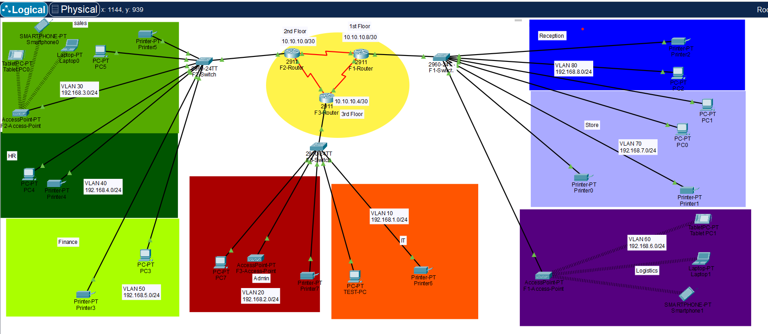

IP ADRESSING SCHEME

ROUTERS
Name: FI ROUTER
Floor: 1st Floor
Subnet: 10.10.10.0/30
Subnet Mask: 255.255.255.252
Network ID: 10.10.10.1/30, 10.10.10.5/30

Name: F2 ROUTER
Floor: 2nd Floor
Subnet: 10.10.10.4/30
Subnet Mask: 255.255.255.252
Network ID: 10.10.10.2/30, 10.10.10.6/30

Name: F3 ROUTER
Floor: 3rd Floor
Subnet: 10.10.10.8/30
Subnet Mask: 255.255.255.252
Network ID: 10.10.10.3/30, 10.10.10.7/30

ROUTER CONFIGURATIONS

Serial DCE Connections and Clock Rate
To establish connectivity between the three routers, serial DCE connections were configured along with appropriate clock rates. The serial interfaces on each router were assigned IP addresses from the designated subnets, and the clock rate was set to 64000 to ensure proper synchronization and communication between the routers.
The clock rate plays a crucial role in synchronizing the transmission of data bits between the routers. Each clock pulse signals the transmission of a single bit, and setting the clock rate to 64000 ensures that the routers can communicate effectively with each other over the serial connections.
Configuring the clock rate is an important step in establishing reliable communication between devices that are connected using serial interfaces. Without a synchronized clock rate, the devices would be unable to interpret the incoming data stream correctly, leading to communication failures and potential data corruption.

By setting the clock rate to a standard value of 64000, the routers are able to transmit and receive data at a consistent rate, ensuring that the bits are interpreted correctly at the receiving end. This synchronization is essential for maintaining the integrity of the data being transmitted and ensuring that the network operates reliably and efficiently.

Example configuration for Router 0 using the router cli:
Interface Serial0/2/1
Ip address 10.10.10.2 255.255.255.252
Clock rate 64000
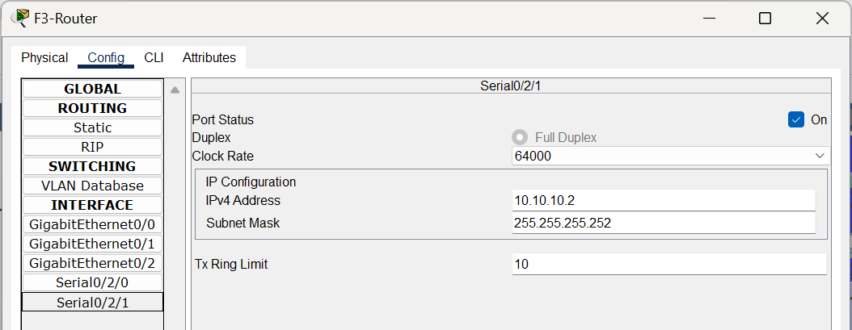

VLAN Configuration
The below table show the VLAN configuration for all departments with their Department name subnet and subnet mask.
floor | Dept. name | Subnet | Vlan | Subnet mask
1st | reception | 192.168.8.0/24 | Vlan 80 | 255.255.255.0
 | Store | 192.168.7.0/24 | Vlan 70 | 255.255.255.0
 | Logistics | 192.168.6.0/24 | Vlan 60 | 255.255.255.0
2nd | Finance | 192.168.5.0/24 | Vlan 50 | 255.255.255.0
 | HR | 192.168.4.0/24 | Vlan 40 | 255.255.255.0
 | Sales | 192.168.3.0/24 | Vlan 30 | 255.255.255.0
3rd | Admin | 192.168.2.0/24 | Vlan 20 | 255.255.255.0
 | It | 192.168.1.0/24 | Vlan 10 | 255.255.255.0

Configuring DHCP Service Pools and Encapsulation
In this example, the router is configured to serve IP addresses from the 192.168.1.0/24 subnet for Reception. The default gateway is set to 192.168.1.1 (the router's LAN interface IP address), and the DNS servers are set to 192.168.8.1

Figure 2.4 router1 (2nd floor) DHCP pools and dns config

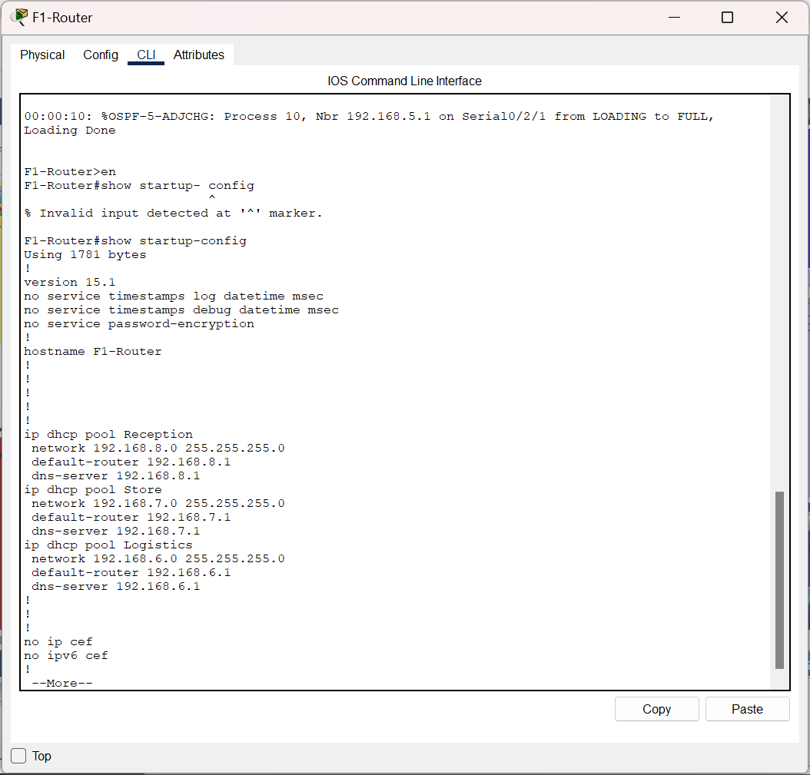

Configuring OSPF Routing Protocol
Each Router has five different network to advertise using area 10
Configure OSPF routing protocol on all routers with Area 10

Example configuration for Router 1: floor 1
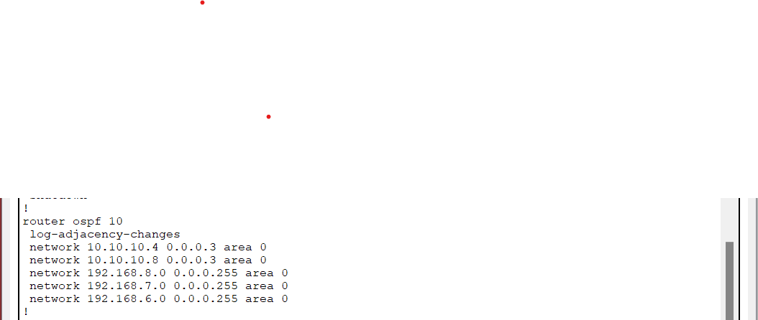

SSH Configuration
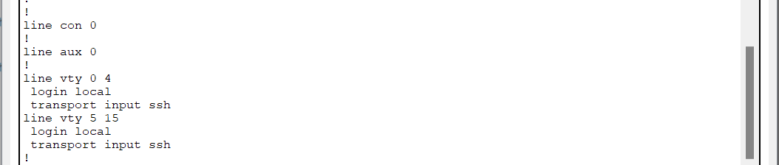

Trunk Links Configuration
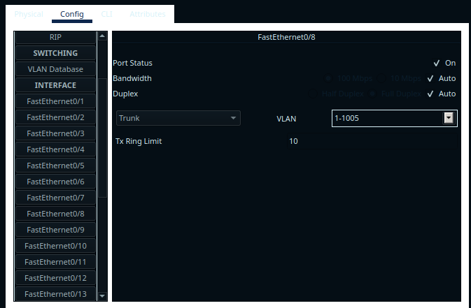

Switch Configurations

VLAN Configuration
Configure VLANs on switches and assign switch ports to respective VLANs.
Example configuration for Switch 1 (1st Floor):
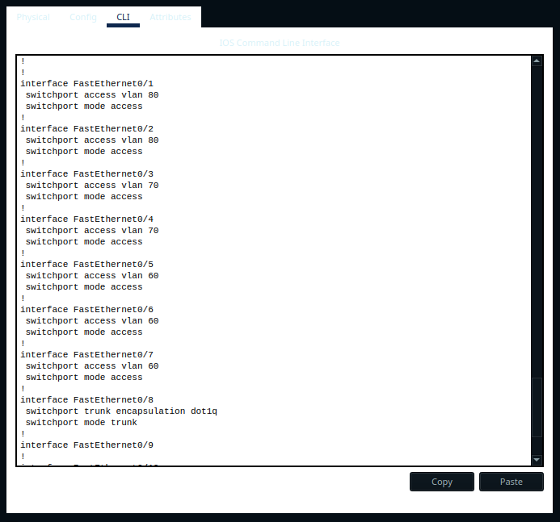

Port Security Configuration (for IT Department Switch)
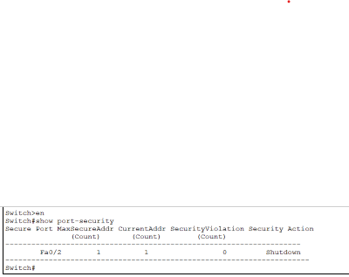
To enforce security measures and restrict access to designated devices, port security will be configured on switches.
Example configuration for the IT department switch (Switch 2 on the 3rd floor):

Interface FastEthernet0/1
Switch port mode access
Switch port access vlan 10
Switch port port-security
Switch port port-security mac-address sticky
Switch port port-security violation shutdown
Switch port port-security maximum1

Wireless Network Configuration

Access point floor 1, 2 and 3 configuration

Floor 1
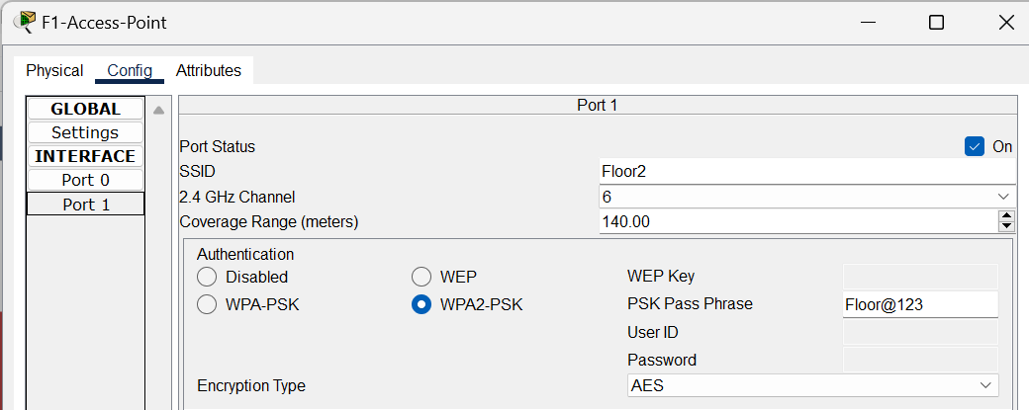

Floor 2
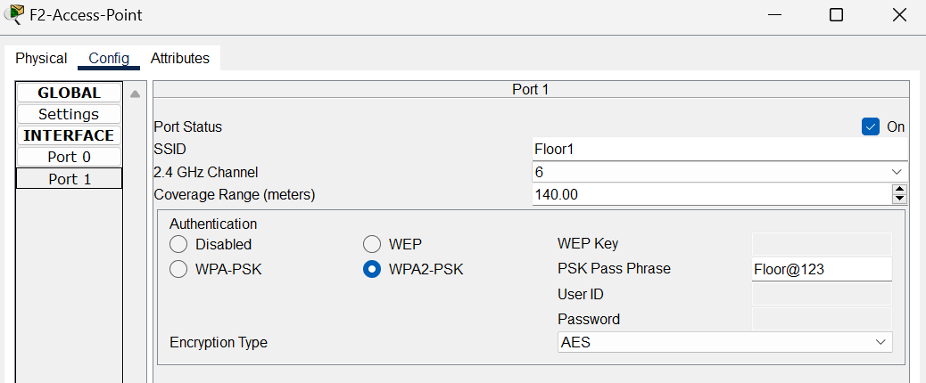

Floor 3
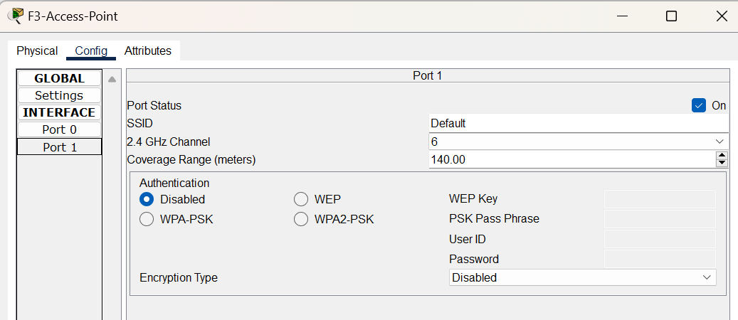

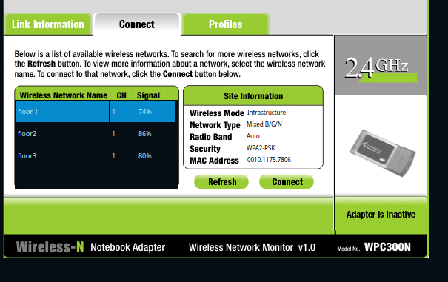

Testing and Verification

Several ping commands from different vlans in the network
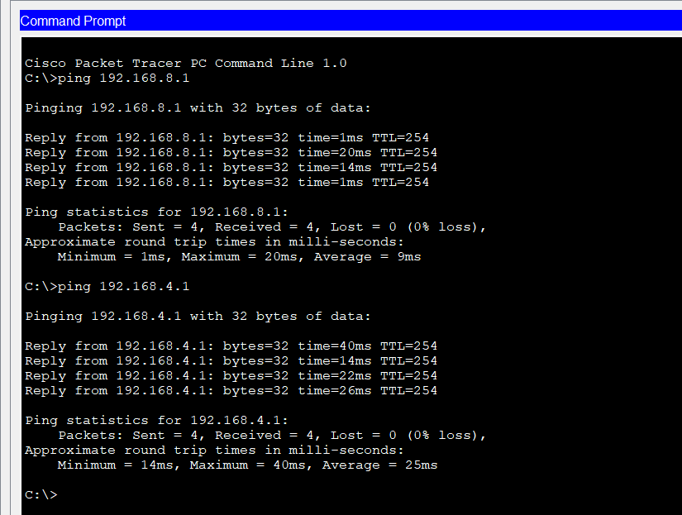

Wap connection
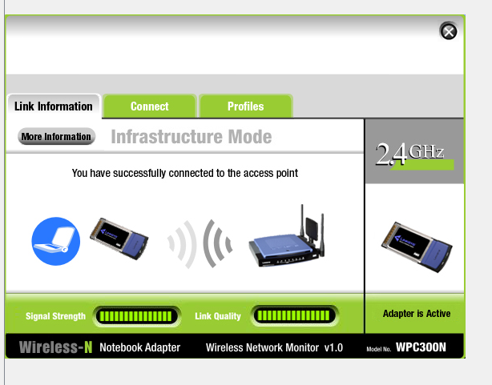

Assigning of ip addresses e.g. floor 2
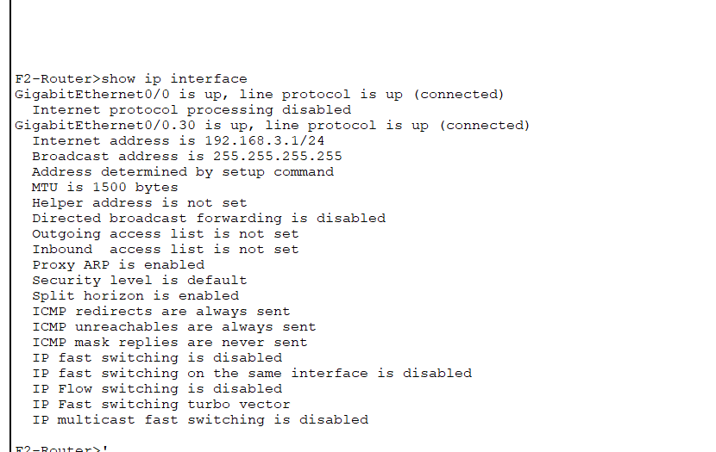

PDU test
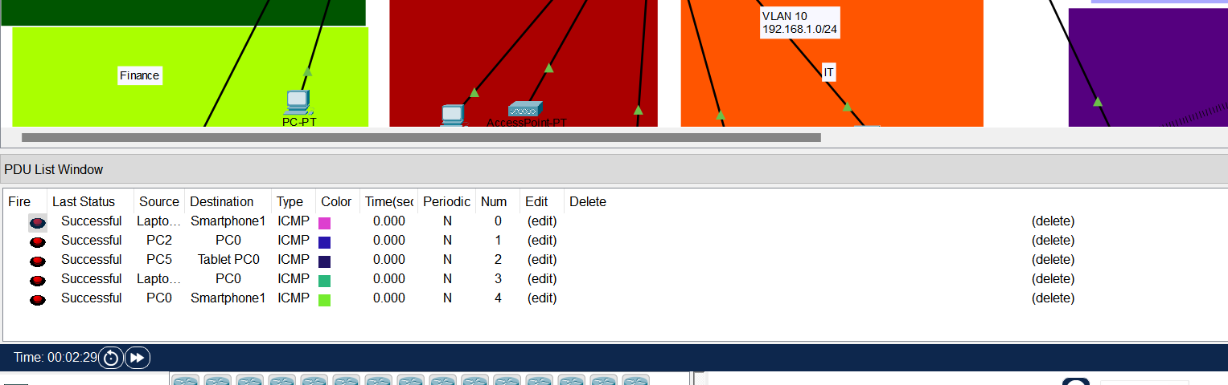

Enhanced Security Measures

Security is paramount in the design and implementation of the Murang’a Modern Hotel network. Building upon the foundational security considerations, several advanced measures have been implemented to fortify the network infrastructure:

- Network Segmentation with Advanced Access Control: VLANs are leveraged not only for logical subnet segmentation but also for advanced access control. Access Control Lists (ACLs) are configured at VLAN interfaces to regulate traffic flow between departments. This granular control ensures that only necessary communication is permitted, minimizing the attack surface and enhancing security posture.

- Two-Factor Authentication (2FA) for Remote Access: In addition to SSH, Two-Factor Authentication (2FA) is enforced for remote access to critical network devices. Authorized IT personnel must authenticate using a combination of username/password credentials and a secondary authentication factor, such as a Time-Based One-Time Password (TOTP) generated by a mobile app or hardware token. This multi-layered authentication approach significantly enhances the security of remote access, thwarting unauthorized intrusion attempts effectively.

- Dynamic Port Security with Real-Time Monitoring: Port security on the IT department switch is bolstered with dynamic monitoring capabilities. In addition to the sticky MAC address assignment, real-time monitoring tools are employed to detect and respond to anomalous port activity. Suspicious behavior triggers immediate alerts, and automated responses, such as port shutdown or quarantine, are activated to mitigate potential security threats promptly.

- Intrusion Detection and Prevention Systems (IDPS): An Intrusion Detection and Prevention System (IDPS) is deployed within the network architecture to provide proactive threat detection and mitigation capabilities. The IDPS continuously monitors network traffic for signs of suspicious activity, including intrusion attempts, malware infections, and unauthorized access. Upon detection, the IDPS initiates rapid response actions, such as blocking malicious traffic, quarantining affected devices, and generating detailed incident reports for further analysis.

- Advanced Encryption Standards for Wireless Security: Building upon the recommendation for WPA2 encryption, the wireless network adopts Advanced Encryption Standards (AES) for robust data encryption. AES, a cryptographic algorithm widely recognized for its security and efficiency, strengthens the confidentiality of wireless communications, safeguarding sensitive information from interception and unauthorized access.

By implementing these advanced security measures, the Murang’a Modern Hotel network not only meets industry standards but exceeds them, ensuring comprehensive protection against evolving cyber threats and preserving the confidentiality, integrity, and availability of data and resources.

Conclusion
The design and implementation of the network infrastructure for the Murang'a Modern Hotel exemplify a comprehensive and robust approach to addressing the communication and operational needs of a thriving hospitality establishment. By leveraging Cisco networking equipment, including routers, switches, and wireless access points, the network architecture ensures seamless connectivity, efficient resource utilization, and enhanced security across the hotel's three floors.
The strategic placement of routers, the strategic assignment of IP addresses and VLANs, and the implementation of dynamic routing protocols like OSPF enable smooth data flow and effective communication between the various departments. The integration of DHCP services, along with the configuration of SSH access and port security measures, further streamlines network management and reinforces the overall security posture.
Notably, the deployment of advanced security mechanisms, such as network segmentation with Access Control Lists, Two-Factor Authentication for remote access, dynamic port security monitoring, and the adoption of robust encryption standards for wireless communications, demonstrates the hotel's commitment to safeguarding its critical infrastructure and sensitive data. These measures not only align with industry best practices but also proactively address emerging cybersecurity threats, positioning the Murang'a Modern Hotel as a leader in the hospitality industry's digital transformation.
Through the meticulous design, thorough configuration, and extensive testing of the network, the Murang'a Modern Hotel has established a reliable, efficient, and secure communication infrastructure that will undoubtedly support its ongoing operations, enhance guest experiences, and contribute to its continued success in the competitive hospitality landscape.

Accomplishments
Hierarchical Network Deployment: Successfully deployed a robust hierarchical network architecture, connecting Murang’a Modern Hotel's three floors with three routers. This architecture ensures efficient communication and resource sharing across departments, laying a solid foundation for seamless operations.
VLAN and Subnet Segmentation: Implemented VLANs and subnet segmentation to enhance network security and performance. By isolating traffic and resources for each department, we have effectively mitigated the risk of unauthorized access and potential security breaches while optimizing network efficiency.
Seamless Wireless Connectivity: Integrated wireless connectivity on each floor, providing seamless mobility and access for employees and guests using laptops and mobile devices. This enhancement enhances productivity and guest satisfaction, meeting the modern connectivity demands of a dynamic hospitality environment.
Centralized DHCP Configuration: Established a centralized DHCP server configuration, ensuring efficient and automated IP address assignment to all network devices. This centralized approach streamlines network management tasks, reducing administrative overhead and ensuring consistent connectivity across the network.
Secure Remote Access: Implemented secure remote access capabilities through SSH, enabling authorized IT personnel to manage and maintain the network infrastructure remotely. This secure communication channel ensures the confidentiality and integrity of administrative tasks and configurations, enhancing overall network security.
Port Security Measures: Incorporated port security measures on the IT department switch, restricting access to authorized devices and enhancing overall network security. By enforcing strict access controls at the port level, we have mitigated the risk of unauthorized access attempts and potential security breaches, safeguarding critical network resources.
These accomplishments represent significant milestones in the design and implementation of the Murang’a Modern Hotel network, demonstrating our commitment to excellence in network infrastructure deployment and security.

